

Lesson Plan template

Math Grade 8 to 12

](https://www.teacherspayteachers.com/Product/Algebra-2-Quadratics-Review-Bundle-5036530)[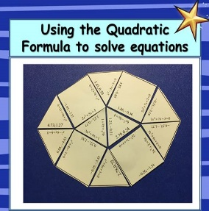](https://www.teacherspayteachers.com/Product/Quadratic-Graph-Transformations-Puzzle-Activity-4499289)[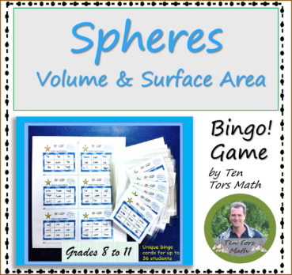](https://www.teacherspayteachers.com/Product/Volume-and-Surface-Area-of-Spheres-Bingo-Game-Activity-4393537)

[Completing the Square](https://www.teacherspayteachers.com/Product/Completing-the-Square-Activity-4993684)

[Percentage Increase and Decrease](https://www.teacherspayteachers.com/Product/Percentage-Increase-Decrease-Task-Cards-4232043)

[Algebra 2 Quadratic Bundle](https://www.teacherspayteachers.com/Product/Algebra-2-Quadratics-Review-Bundle-5036530)

[The Quadratic Formula](https://www.teacherspayteachers.com/Product/Solving-Quadratic-Equations-with-Quadratic-Formula-activity-4011782)

[Quadratic Graph Transformations](https://www.teacherspayteachers.com/Product/Quadratic-Graph-Transformations-Puzzle-Activity-4499289)

[Volume & Surface Area of Spheres](https://www.teacherspayteachers.com/Product/Volume-and-Surface-Area-of-Spheres-Bingo-Game-Activity-4393537)

Some math activities you may like! (Ctrl click the link)

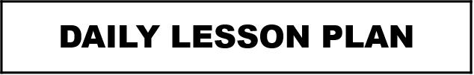

Lesson Title: __________________________________________________

Teacher: __________________________

|  |
| --- |
| Lesson Objectives |
|  |

|  |
| --- |
| Equipment Needed: |
|  |

|  |  |
| --- | --- |
| Lesson Sequence | |
| Summary of Activities | Timing |
| Summative:  Wrap Up / Plenary:  Lesson Starter / Bell work: |  |

|  |
| --- |
| Differentiation / Extensions |
|  |

|  |
| --- |
| Assessments: |
| Formative: |

|  |
| --- |
| www.tentorsmath.com |

|  |
| --- |
| **Standards:** |
| Choose an item. |
| Choose an item. |
| Choose an item. |
| Choose an item. |

Grade Level: ___9 to 12

Notes / Reflections

Subject / Course: _______________________________________________________

Period: _____________

Main:

Date: ____________________