Teacher: __________________________
Lesson Title: __________________________________________________
Lesson Objectives
Equipment Needed:
Lesson Sequence
Summary of Activities | Timing
Summative:
Wrap Up / Plenary:
Lesson Starter / Bell work:
Differentiation / Extensions
Assessments:
www.tentorsmath.com
Standards:
Choose an item.
Choose an item.
Choose an item.
Choose an item.
Grade Level: ___________
Notes / Reflections
Subject / Course: _______________________________________________________
Period: _____________
Main:
Date: ____________________
Formative:

Thank you for downloading my lesson planning template – I hope you fingd it useful.

If you are also a math teacher you may also be interested in some of my other resources; here is a sample of a few of them:
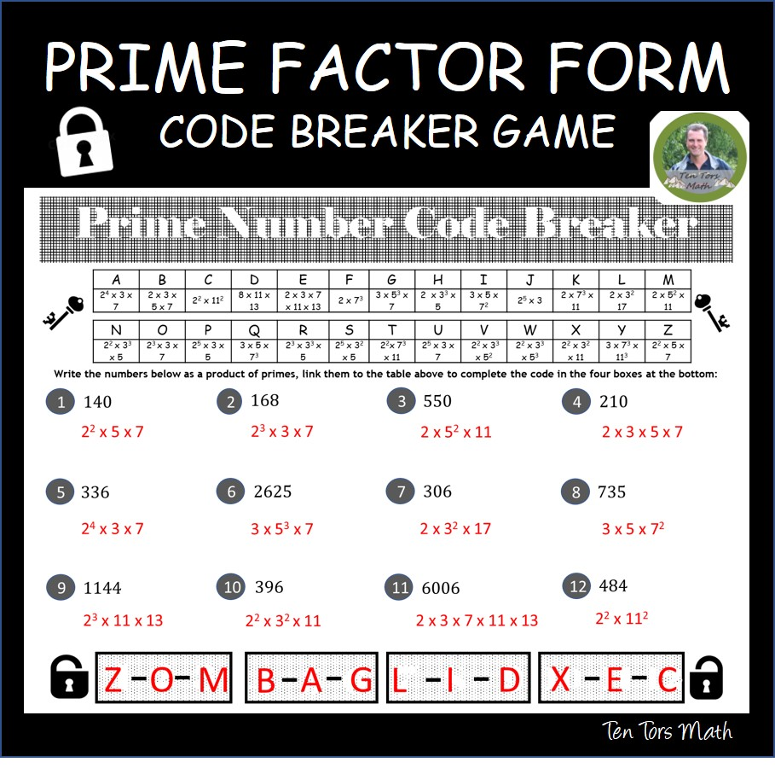
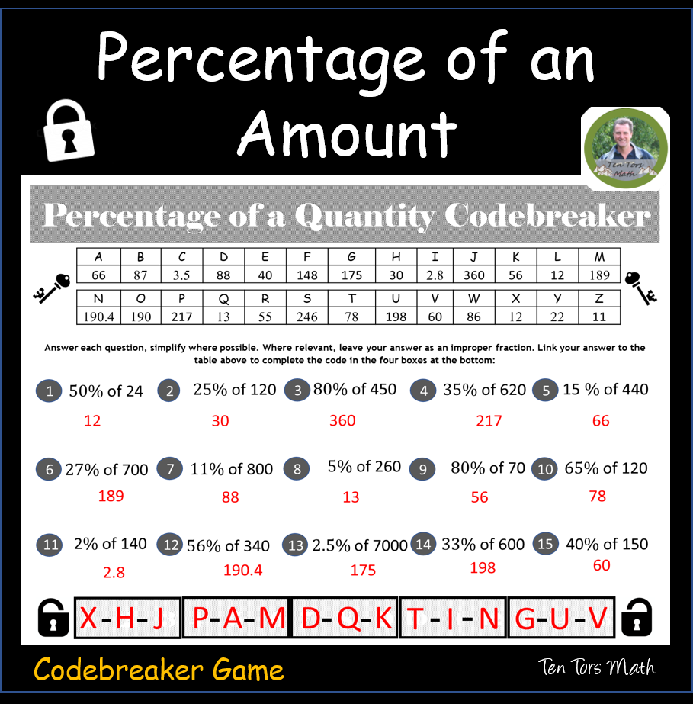
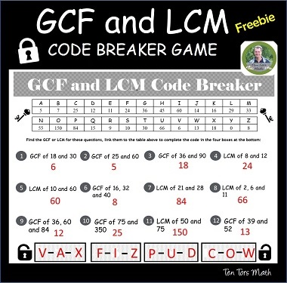
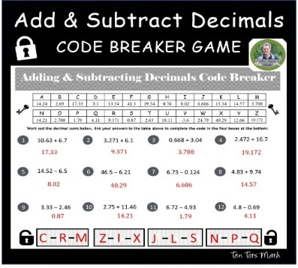
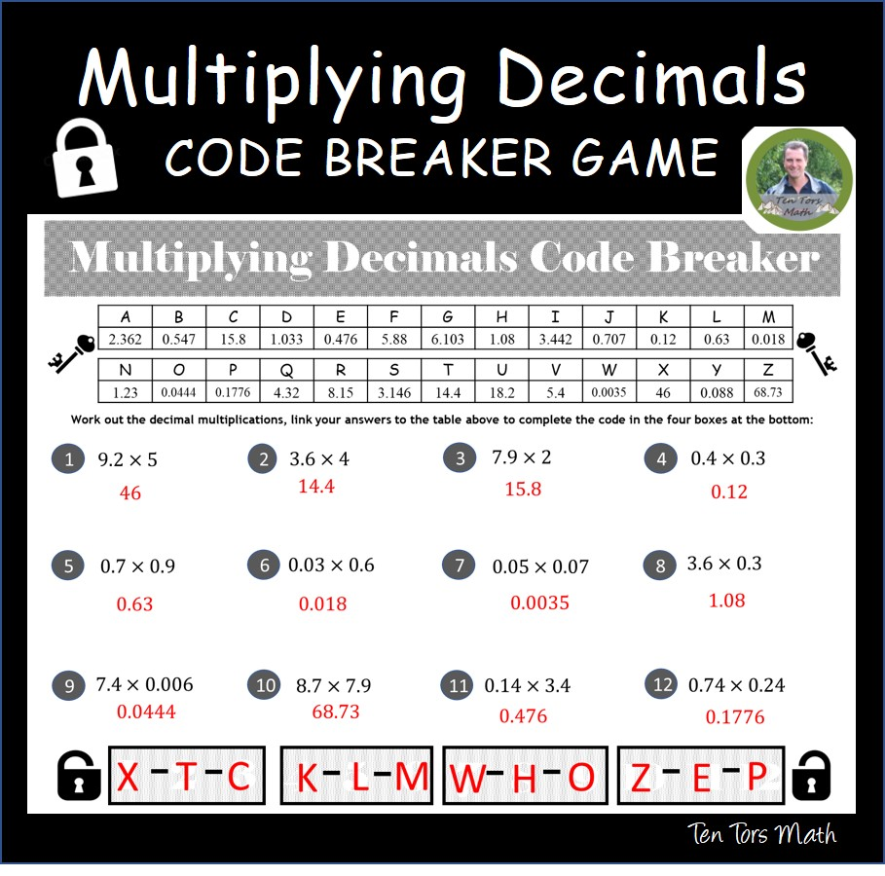
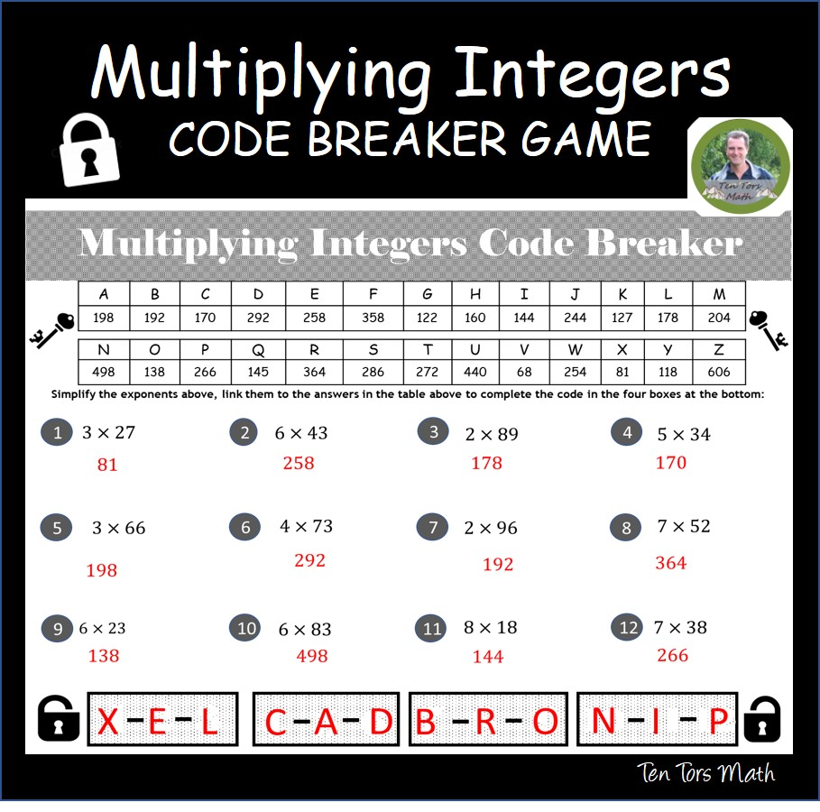
Prime Factors
GCF LCM
Add Subtract Decimals
Some math code-breakers you may like! (Ctrl click the link)
Percentage of an Amount
Multiplying Decimals
Multiplying Integers

